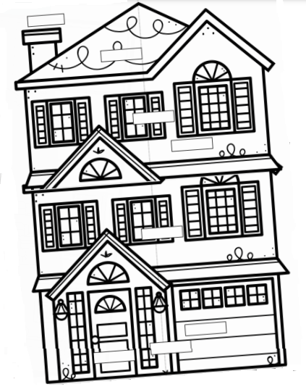

GARAGE

DOOR

GROUND FLOOR

CHİMNEY

WİNDOW

FİRST FLOOR

SECOND FLOOR

ROOF